**ASSIGNMENT 5**

**Question:01**

A program that reads two 2-d arrays as 3*3 matrices then calculates and stores their product into another 2-d array of size 3*3. (Note: Array A and Array B must be prompted by user at run-time)

Array A

|  |  |  |
| --- | --- | --- |
| 3 | 5 | 6 |
| 1 | 9 | 2 |
| 12 | 10 | 7 |

Array B

|  |  |  |
| --- | --- | --- |
| 4 | 6 | 7 |
| 2 | 3 | 5 |
| 3 | 8 | 6 |

**SOURCE CODE**

#include <iostream>

using namespace std;

int main()

{

int a[10][10], b[10][10], mult[10][10], r1, c1, r2, c2, i, j, k;

cout << "Enter rows and columns for first matrix: ";

cin >> r1 >> c1;

cout << "Enter rows and columns for second matrix: ";

cin >> r2 >> c2;

// If column of first matrix in not equal to row of second matrix,

// ask the user to enter the size of matrix again.

while (c1!=r2)

{

cout << "Error! column of first matrix not equal to row of second.";

cout << "Enter rows and columns for first matrix: ";

cin >> r1 >> c1;

cout << "Enter rows and columns for second matrix: ";

cin >> r2 >> c2;

}

// Storing elements of first matrix.

cout << endl << "Enter elements of matrix 1:" << endl;

for(i = 0; i < r1; ++i)

for(j = 0; j < c1; ++j)

{

cout << "Enter element a" << i + 1 << j + 1 << " : ";

cin >> a[i][j];

}

// Storing elements of second matrix.

cout << endl << "Enter elements of matrix 2:" << endl;

for(i = 0; i < r2; ++i)

for(j = 0; j < c2; ++j)

{

cout << "Enter element b" << i + 1 << j + 1 << " : ";

cin >> b[i][j];

}

// Initializing elements of matrix mult to 0.

for(i = 0; i < r1; ++i)

for(j = 0; j < c2; ++j)

{

mult[i][j]=0;

}

// Multiplying matrix a and b and storing in array mult.

for(i = 0; i < r1; ++i)

for(j = 0; j < c2; ++j)

for(k = 0; k < c1; ++k)

{

mult[i][j] += a[i][k] * b[k][j];

}

// Displaying the multiplication of two matrix.

cout << endl << "Output Matrix: " << endl;

for(i = 0; i < r1; ++i)

for(j = 0; j < c2; ++j)

{

cout << " " << mult[i][j];

if(j == c2-1)

cout << endl;

}

return 0;

}

**OUTPUT**

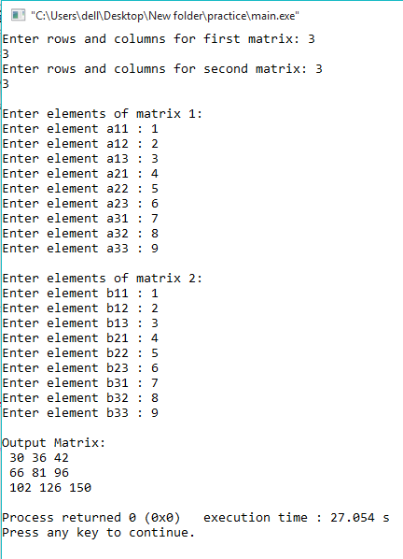

**Question:02**

A program that initializes the 2-D arrays of 4*4 matrices. The initialized value must be mixed integer means positive and negative both values. Compute the sum of only negative values and print that value.

**SOURCE CODE**

#include <iostream>

using namespace std;

int main()

{

int a[10][10], b[10], r1, c1, i, j, k, sum=0;

cout << "Enter rows and columns for first matrix: ";

cin >> r1 >> c1;

// If column of first matrix in not equal to row of second matrix,

// ask the user to enter the size of matrix again.

while (c1!=r1)

{

cout << "Error! column of first matrix not equal to row of second.";

cout << "Enter rows and columns for first matrix: ";

cin >> r1 >> c1;

}

// Storing elements matrix.

cout << endl << "Enter elements of matrix 1:" << endl;

for(i = 0; i < r1; ++i)

for(j = 0; j < c1; ++j)

{

cout << "Enter element a" << i + 1 << j + 1 << " : ";

cin >> a[i][j];

}

// Adding negative elements of matrix

for(i = 0; i<r1; i++)

{

for(j=0; j<c1; j++)

{

if(a[i][j]<0)

{

sum += a[i][j];

}

}

}

cout<<sum<<" is the sum of all negative numbers in the array"<<endl;

return 0;

}

**OUTPUT**

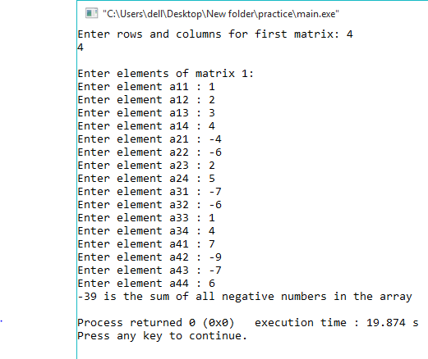

**Question:03**

Write a program to follow 3-d array. Which takes input in 5*5*3 matrices. Let suppose there are 5 students in a class with 5 different courses and there are 3 marks scales i.e. assignment, mid-term and final. Take all these values at run time by user and print the data.

**SOURCE CODE**

#include <iostream>

#include <string.h>

using namespace std;

int main()

{

// This array can store upto 12 elements (2x3x2)

int test[5][5][3];

cout << "Enter values: \n";

// Inserting the values into the test array

// using 3 nested for loops.

for(int i = 0; i < 5; ++i)

{

for (int j = 0; j < 5; ++j)

{

for(int k = 0; k < 3; ++k )

{

cin >> test[i][j][k];

}

}

}

cout<<"\nDisplaying Value stored:"<<endl;

// Displaying the values with proper index.

for(int i = 0; i < 5; ++i)

{

for (int j = 0; j < 5; ++j)

{

for(int k = 0; k < 3; ++k)

{

cout << "test[" << i << "][" << j << "][" << k << "] = " << test[i][j][k] << endl;

}

}

}

return 0;

}

**OUTPUT**

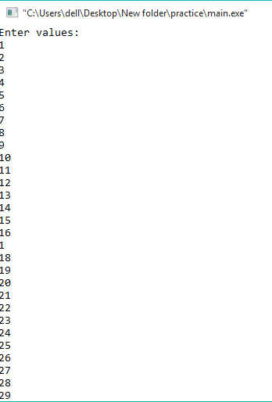

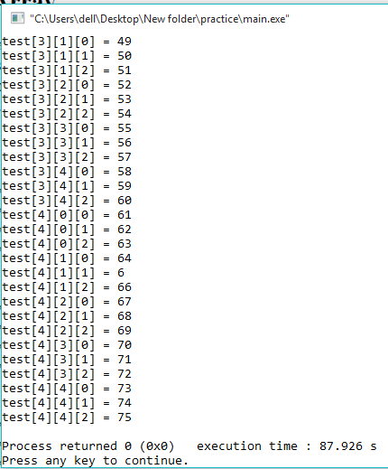

**Question:04**

Using concept of string. Initializes two strings i.e. Pakistan and Australia. Using the **built-in-functions**, reverse them using function (strrev) and then concatenate the reverse strings using (strcat) and finally compute the length of concatenated string.

**SOURCE CODE**

#include <iostream>

#include <string.h>

using namespace std;

int main()

{

char a[10]="Pakistan", b[10]="Australia";

cout<<"The 1st sting is "<<a<<endl;

cout<<"The 2nd sting is "<<b<<endl<<endl;

cout<<strrev(a)<<endl<<endl;

cout<<strrev(b)<<endl<<endl;

cout<<strcat(a,b)<<endl<<endl;

cout<<strlen(a)<<endl;

return 0;

}

**OUTPUT**

